**DAILY ONLINE ACTIVITIES SUMMARY**

|  |  |  |  |  |  |  |  |  |
| --- | --- | --- | --- | --- | --- | --- | --- | --- |
| **Date:** | **12/07/2020** | | | | | **Name:** | **VIRESH** | |
| **Sem & Sec** | **4th SEM & ‘B’ SEC.** | | | | | **USN:** | **4AL18CS097** | |
| **Online Test Summary** | | | | | | | | |
| **Subject** | | **-------** | | | | | | |
| **Max. Marks** | | **---** | | **Score** | | | **---** | |
| **Certification Course Summary** | | | | | | | | |
| **Course** | **Introduction to Digital Marketing.** | | | | | | | |
| **Certificate Provider** | | | **Greatlearning Academy** | | **Duration** | | | **2.5 Hrs.** |
| **Coding Challenges** | | | | | | | | |
| **Problem Statement 1:** ---------- | | | | | | | | |
| **Status: ---** | | | | | | | | |
| **Uploaded the report in Github** | | | | | **Yes** | | | |
| **If yes Repository name** | | | | | **Lockdown-Coding**  <https://github.com/viresh-kulal/Lockdown-Coding>  <https://github.com/alvas-education-foundation/Viresh/tree/master/coding_solutions> | | | |
| **Uploaded the report in slack** | | | | | **Yes** | | | |

**Online Test Summary: No internals Conducted Today.**

**Online Certification Course Summary: Today I have gone through explanation about new medias.**

**The snapshots of today’s session is attached below.**

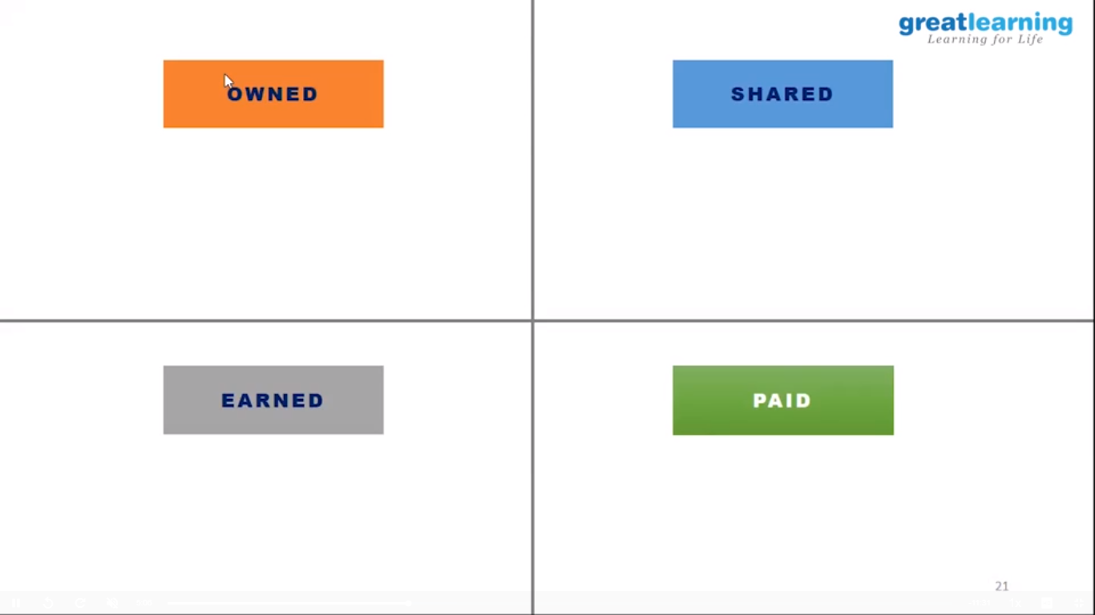 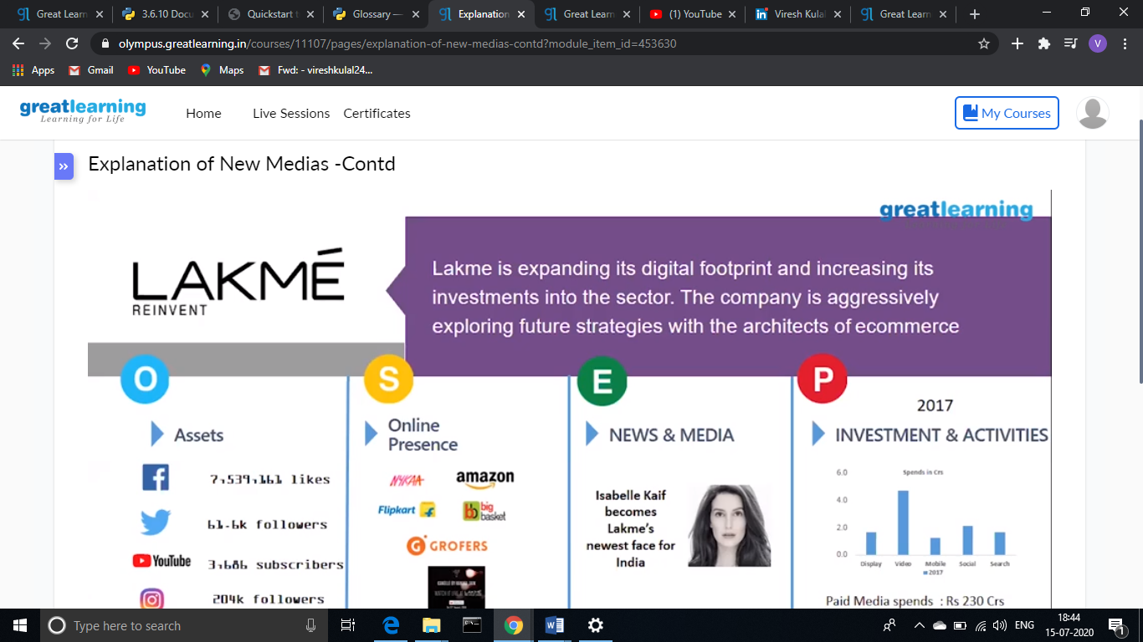

**Online Coding Summary: No problem statements were given.**

The Repository link is: <https://github.com/viresh-kulal/Lockdown-Coding>

<https://github.com/alvas-education-foundation/Viresh/tree/master/coding_solutions>

**Thank you.**